- Infi Leaf Wetness Sensor
Description
Infi Leaf Wetness Sensor was developed to provide users with a robust and low-maintenance alternative to the traditional style sensors using sheets of paper or human or animal hair. A grid of conductive tracks, etched onto a Teflon-coated ceramic plate reliably simulates the surface of a leaf and outputs a range of readings between 0 %and 100%

Specifications
Measurement Time | 10 ms
Power | 2.5 Vdc @ 2 mA to 5 Vdc @ 7 mA
Output | 250 to 1500 mV
Operating Temperature Range | -40° to +60°C
Life Expectancy | 2+ years (continuous use)
Dimensions | 12.0 x 5.8 x 0.8 cm (4.7 x 2.3 x 0.3 in.)
Weight | 0.14 kg (5 oz) with 4.57 m (15 ft) cable

Benefits and Features
- Imitates characteristics of a leaf
- Does not require painting or calibration of individual sensors
- Detects trace amounts of water or ice on the leaf surface
- Easy To Install
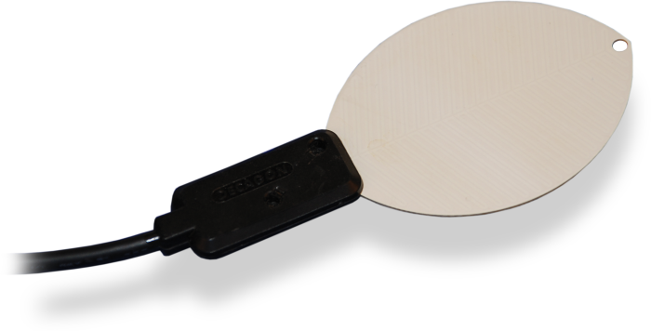
Working
There is a fixed frequency oscillator that is built with a 555 Timer IC. The square wave generated is then fed to the sensor like a capacitor. To a square wave signal that capacitor, however, has a certain reactance, or for argument’s sake a resistance that forms a voltage divider with a pure ohm type resistor (the 10k one on pin 3). The greater is the Wetness on Leaf, the higher the capacitance of the sensor. Consequently, there is a smaller reactance to the square wave, thus lowering the voltage on the signal line. The voltage on the Analog signal pin can be measured by an analog pin on the Arduino which represents the Wetness in the Leaf.

